Fishing Regulation Proposal Form A – Special Regulation
Proposed Regulation
No minimum length limit, 14-18 inch protected slot, 3 fish daily bag limit (1 > 18”) for bass
Current Regulation
Statewide 14-inch minimum size limit, 5 fish daily bag limit
Author  Gregory Matzke |  | Date  12/10/13 ←modified
Location Information
Affected water(s)
The Spread Eagle Chain of Lakes, Keyes Lake and Halsey Lake
County(ies)  Florence County | WBIC(s)  SECL(West-0703500, South-0702200, RR-0702800, North-0703000, Middle-0702600, Long-0702500, East-0702400, Bass-0702700), 0672900, 0679300
Upstream/downstream boundaries, if applicable – Law Enforcement should be consulted
Law Enforcement supports this regulation change (Contact: Kelly Crotty)
Description of the Water and Fishery
Florence County is listed as having a total of 256 lakes. However, most of these lakes do not support a fishery and are better suited for waterfowl and wildlife management. There are only a few water bodies in Florence County that support manageable fisheries, and these lakes receive the majority of the fishing pressure within the county. Over the past 3 years my fisheries team has surveyed every waterbody over 75 acres that has a public boat landing in Florence County (excluding the WI-MI border flowages). The surveys conducted on these 10 lakes were very comprehensive. Population estimates were attempted on all gamefish species and spring and summer panfish surveys were completed. Data was collected to evaluate abundance, size structure, growth, body condition and recruitment for all species. After analyzing the data from the past three years it is clear that the statewide 14-inch minimum size limit is not a good fit for a few of these waters. Below I will go over these three fisheries in more detail.

Provide a brief description of the water(s)

Spread Eagle Chain of Lakes
Lake and location:
Spread Eagle Chain of Lakes, Florence County, T.40N. R.19E. Sec. 32-34

Eight lakes make up the Spread Eagle Chain of Lakes: Bass, East, Long, Middle, North, Railroad, South and West Lakes.

Located in the NE corner of Florence County, between Florence and Iron Mountain. The Spread Eagle Chain of Lakes is part of the Menominee River watershed. The outlet of the SECL flows directly into the Menominee River.

Physical/Chemical attributes: (Young, 2005)
Morphometry: 548 acres, maximum depth of 75 feet
Lake type: Drainage (one permanent inlet, outlet to Menominee River)
Basic water chemistry:. Hard – alkalinity 99 mg/L, conductance 208 umhos (averages)
Water clarity: Clear
Littoral substrate: 37% gravel, 36% sand, 16% muck, 13% rubble and 3% boulder
Aquatic vegetation: Variable – sparse to moderate
Shoreline character: Predominantly upland
Shoreline development: High
Winterkill: None reported or likely
Boat landing: One public boat landing on North Lake
Other features: Many docks and boat houses

Keyes Lake

Lake and location:
Keyes Lake, Florence County, T.40N. R.17E.

Located just southwest of the intersection of highways 101 and 70, between Florence and Tipler. Keyes Lake flows downstream to the Pine River and is located within the Menominee River watershed.

Physical/Chemical attributes: (Young, 2006)
Morphometry: 202 acres, maximum depth of 77 feet
Lake type: Spring (one outlet to Sea Lion Lake)
Basic water chemistry: Med. Hard – alkalinity 49 mg/l, conductance 157 umhos
Littoral Substrate: 45% sand, 45% gravel, 10% muck
Water clarity: Clear
Aquatic vegetation: Common in shallow areas
Shoreline character: 100% upland
Shoreline development: High (avg. 1 dwelling every 200 feet of shoreline)
Winterkill: None reported or likely
Boat landing: One public boat landing
Shoreline Length: 3.2 miles

Halsey Lake

Lake and location:
Halsey Lake, Florence County, T.39N. R.15E. Sec. 16, 20 and 21

Located in west central Florence County, two miles east of the town of Long Lake. Halsey Lake is part of the Menominee River watershed and is drained by the Pine River.

Physical/Chemical attributes:
Morphometry: 512 acres, maximum depth of 10 to 12 ft.
Lake type: Drainage (one inlet, outlet to Fay Lake which drains to the Pine River)
Basic water chemistry:. Neutral (pH 6.8-7.5), Hard water – alkalinity 102 mg/L.
Water clarity: Clear
Aquatic vegetation: Submergent is sparse, moderate emergent vegetation
Shoreline character: approximately 50% wetland and 50% upland
Shoreline development: Low
Winterkill: Infrequent winterkill, but may winterkill during extremely harsh winters.
Boat landing: One public boat landing
Other features: There is very shallow water (0.5-2 feet) on the NE and SW ends of lake

Fishery Description:

The Spread Eagle Chain of Lakes (SECL) was surveyed during 2011 with a variety of sampling gear to assess the status of the fishery. Sampling began with early spring fyke netting and electrofishing for adult gamefish, followed by a late spring fyke netting survey for muskellunge, summer fyke netting assessment of the panfish population and sampling was completed with a fall electrofishing survey to assess gamefish recruitment. A follow-up fyke netting survey was conducted during late spring 2012 as part of a two year muskellunge population assessment.

Five gamefish species were captured during our survey of the SECL. Walleye and muskellunge appear to have some form of limited natural reproduction although they are not capable of maintaining their populations naturally. Northern pike, largemouth and smallmouth bass have sufficient natural reproduction to maintain their current populations. Largemouth bass are the most abundant gamefish species (7.41 adults/acre), followed by northern pike, smallmouth bass, walleye (0.36 adults/acre) and muskellunge (0.10 adults/acre).

Largemouth bass, smallmouth bass and northern pike have moderate to poor size structure with many quality sized fish but few preferred size fish. However, these populations do have trophy potential with large individuals captured during our survey. Walleye have an artificially high size structure created by minimal recruitment over the past 7 years. This size structure is not sustainable and should reduce itself if the population were to grow through stocking. Muskellunge are relatively young in the SECL, but display impressive growth rates and surprising size structure.

Seven panfish species were captured during the 2011 survey. Bluegill is the most abundant panfish species in the SECL. Black crappie and rock bass also offer angling opportunities, but have much smaller populations than bluegill. In general panfish have good growth rates, but lack preferred size fish. This suggests that angler harvest is limiting panfish potential on the SECL. A more restrictive regulation on all panfish would improve the quality of the panfish populations.

Only two non-game species were captured during our survey work. These species were golden shiner and white sucker. Neither species was captured with any frequency suggesting low population levels.

Keyes Lake was surveyed during 2012 with a variety of sampling gear to assess the status of the fishery. Sampling began just after ice out, with early spring fyke netting for walleyes and other adult gamefish, followed by three early spring electrofishing surveys to estimate the adult walleye population. Electrofishing continued to assess the bass populations followed by summer fyke netting for panfish, experimental gill netting for cold water fish species, fall electrofishing to assess gamefish recruitment and the survey was wrapped up with spotlighting and netting surveys for lake whitefish.

Four cool water gamefish species were captured during our survey of Keyes Lake. Of these, walleye is the only gamefish that is currently not capable of maintaining its population naturally. The main cause for failed walleye recruitment is the presence of rainbow smelt (documented in 2000). Northern pike, largemouth and smallmouth bass have sufficient natural reproduction to maintain their current populations. Largemouth bass are the most abundant gamefish species, likely followed by smallmouth bass and northern pike, which have much smaller populations.

The walleye population is at its lowest documented abundance (0.45 adults/acre). While walleye abundance had been decreasing since the late 1970s, the introduction of rainbow smelt halted natural recruitment around the year 2000. Starting in 2006, large fingerling walleyes have been stocked into Keyes Lake in an attempt to maintain a fishable population without natural recruitment. Most of these stocked fish have not yet reached adulthood and that is reflected in the low adult population. With steady stocking the adult density should increase over the upcoming years. The largemouth bass population has increased drastically over the last decade, creating a population with many quality sized fish. However, the percentage of fish > 15 inches is relatively low, likely due in part to below average growth rates. Smallmouth bass are just the opposite. Abundance of smallmouth bass has been declining, leaving a population with average growth and good size structure. Northern pike appear to be similar in abundance when compared to smallmouth bass. The sample of the northern pike population taken in 2012 showed average growth and poor size structure.

Two cold water gamefish species, brown trout and lake whitefish, were captured during the 2012 survey. Brown trout do not appear to be capable of natural reproduction and a small adult population is maintained through yearly stocking events, which started in 2002. The brown trout population was created to provide a cold water predator in hopes that their presence would control the rainbow smelt population. Lake whitefish are native to Keyes Lake and have been capable of maintaining their population through natural reproduction. However, all of the lake whitefish sampled were very large/old fish which leaves some questions about the viability of the population.
Five panfish species were captured during the 2012 survey. Bluegill is the most abundant panfish species in Keyes Lake. Rock bass and black crappie also offer angling opportunities, but have much smaller populations than bluegill. Yellow perch are extremely rare and pumpkinseed is likely present although none were sampled during 2012. Of the three major panfish species bluegill and black crappie have above average growth rates with very good size structure. Rock bass are slow growing and have relatively poor size structure in Keyes Lake.

Five non-game species were captured during our survey work. These species were rainbow smelt, white sucker, creek chub, yellow and black bullhead. None of these species were captured with any frequency suggesting low population levels. However, rainbow smelt have proven the ability to become very abundant and have had negative impacts on the Keyes Lake fishery. The current rainbow smelt population is being held in check by a number of cold and cool water predators, but even at the current low population level rainbow smelt are greatly reducing walleye recruitment.

Halsey Lake was surveyed during 2013 using a variety of sampling gear to assess the status of the fishery. Halsey Lake is a drainage lake with a predominantly muck/sand/coble substrate. Halsey Lake is the largest lake in Florence County covering 512 acres and achieving a maximum depth of 10 to 12 feet.

A mark-recapture survey of Halsey Lake's adult walleye population was conducted from May 3-6, 2013. Based on those results, Halsey Lake is estimated to contain 679 adult walleye (1.3/acre). All of the adult walleye were larger than 15 inches. The largest walleye captured was a 27.2-inch female.

Largemouth bass were captured during our spring fyke net survey, walleye electrofishing survey and 4 nights of bass electro-fishing to estimate the adult population. The relative abundance of largemouth bass in Halsey Lake was very high (30.5 fish/mile) when compared to other waters in this region of Wisconsin, and is the highest relative abundance of largemouth bass in Florence County (out of the 10 waters surveyed 2011-13). Size structure of largemouth bass in Halsey Lake is very poor. The majority of the largemouth bass captured (55.6%) were 8.0-9.9 inches in length and only 17 fish (4.8%) were larger than 14 inches.

A total of 43 different northern pike were captured during four days of spring netting in early May. We did not capture enough northern pike to estimate their adult population. Northern pike are the third most abundant game fish in Halsey Lake with a catch rate of approximately 2.7 fish per net-lift. Size structure of northern pike was quite good in Halsey Lake with 88.4% and 20.9% of the pike sampled being > 21.0 and 28.0 inches respectively.

Yellow perch are the most abundant panfish species in Halsey Lake. During our spring netting survey we captured a total of 3,765 yellow perch, this is a catch rate of approximately 235 fish per net-lift. Of these fish captured a random sample of 289 yellow perch were measured during the first day of spring fyke netting, showing poor size structure with only 8.0% of the yellow perch being > 8.0 inches in length. There were no large yellow perch sampled during the 2013 spring survey.

A total of 253 bluegill were captured during a 4-day panfish survey conducted 6/25-28/2013. Relative abundance of bluegill was approximately 12.7 fish per net-lift, making them the 2nd most abundant panfish species in Halsey Lake. Size structure of bluegill in Halsey Lake is quite good with 77.8% and 30.6% of bluegill being > 6.0 and 8.0 inches respectively.

Halsey Lake has a relatively low abundance of bullheads. Over the 4-day panfish survey we captured a total of 134 bullhead or approximately 6.7 fish per net-lift. We captured two different species of bullhead in Halsey Lake during 2013. Black bullhead, accounting for 60.4% of the bullhead catch, appears to be slightly more abundant than yellow bullhead. This low density bullhead population has allowed for a very respectable size structure. Approximately 60.0% of the black bullhead sampled was > 12.0 inches. Yellow bullhead, which are typically smaller than black bullhead, have an even more impressive size structure with 56.6% > 11.0 inches and some individuals present > 14.0 inches (which is considered to be the trophy length for yellow bullhead).

A total of 1,186 white suckers were captured during our spring fyke net survey. This average catch rate of 74.1 fish per net-lift suggests that white sucker are very abundant in Halsey Lake. A random sample of 92 white sucker was measured during the first day of netting to assess size structure. White sucker size structure is quite high with 97.8% and 26.1% of the white suckers measured being > 10.0 and 16.0 inches respectively.

What is the stocking history over the past 20 years? What are the current stocking plans for the future?

SECL Known Stocking History:
Bluegill - adults, 1939
Largemouth Bass - fingerlings, 1942
Muskellunge - large fingerlings, even years 2002-2008 (Private), 2012 (WDNR)
Muskellunge - yearlings, 2004 (Private)
Rock Bass - adult, 1939
Smallmouth Bass - fingerlings, 1941 and 1943
Walleye - fry, 1937, 1938 and 1940-1944
Walleye - fingerlings, 23 of 67 years between 1945 and 2011
Walleye - large fingerlings, 2011 (Private)
Yellow Perch - adults/fingerlings, 1939
**Future stocking consists of Lg Fgl walleye and muskellunge stocked every other year**

Keyes Lake Known Stocking History:
Bluegill - adults, 1939
Black Crappie - adults, 1938
Brook Trout - fingerling, 1957
Brown Trout - lg. fingerlings, 2002-2012
Lake Trout - fry, 1937 and 1946
- lg. fingerlings, 1977 and 1980
Largemouth Bass - fingerlings, 1937
Rainbow Trout - lg. fingerlings, 1955-59 and 1961-62
- yearlings, 1960 and 1963-65
Smallmouth Bass - fingerlings, 1941-44 and 1949-50
Splake - yearlings, 1966-1968
Walleye - fry, 1937-44,
- sm. fingerlings, 2002-2004
- lg. fingerlings, 1950, 1952-54, 2004-2009 and 2011
Yellow Perch - fingerlings, 1939
- adults, 1939
**Future stocking plans include: Lg Fgl walleye stocking every other year, and Lg Fgl brown trout annually**

Halsey Lake Known Stocking History:
Bluegill -adults, 1999
Hybrid Sunfish -fingerling, 1996
Largemouth Bass -adults, 2004
Northern Pike -fry, 7 of 11 years 1940-50
-fingerlings 1989-94, 2011 & 2013
Smallmouth Bass -fingerlings, 1942 & 1946
Walleye -fry & fingerlings, 26 of 66 years 1946-2011
**This lake is a relatively low priority for WWI Lg Fgl walleye, based on availability of product and ranking system set by the “Walleye Team” it may continue to be managed as a walleye lake, if walleye are not available I will try to establish a fishable northern pike population**

Have there been any significant management actions (e.g. habitat work, chemical reclamation, etc.) or major anthropogenic disturbances (e.g. water quality changes, invasives, water level manipulations etc.) on the water in the past 20 years?

Keyes Lake and the SECL both have relative young populations of zebra mussels. Keyes Lake also has a small smelt population and the SECL has EWM.

Other than invasive species no un-natural changes.

How often was the waterbody surveyed in the past 20 years and what type of surveys were conducted?

SECL Past Management Activities:
- May 31-June 9, 1949 (Burdick) – Summer fyke net survey
- August 23, 1966 (Burdick) – Electrofishing survey
- April 29-Sept 13, 1979 (Heizer) – Comprehensive fisheries survey
- September 15, 1993 (Heizer) – Fall electrofishing survey
- September 8, 1994 (Rhode) – Fall electrofishing survey
- July 23, 1996 (Heizer) – Lake Habitat Survey
- April 11, 1998-October 12, 1998 (Heizer) – Comprehensive fisheries survey
- June 13-15, 2005 (Young) – Panfish netting survey
- 2011 (Matzke) – Comprehensive fisheries survey
- 2011 & 2013 – Fall gamefish recruitment surveys

Keyes Lake Past Management Activities:
- 1949 (Burdick) – Fyke net survey/rock bass removal (1,890 rock bass were removed during 13 days of netting; abundant, slow-growing panfish population was found)
- 1949 (Burdick) – Gill net survey for coldwater fishes (no coldwater fish captured).
- 1956 (L.F.) – Gill/fyke net survey (showed large/fast growing whitefish population and good rainbow trout population).
- 1959 (Burdick) – Winter creel during a fishing tournament (RBT was main catch followed by YP, anglers were pleased with the fishing on the lake).
- 1965 (Burdick) – Gill/fyke net survey and electrofishing used to evaluate whitefish, rainbow trout and lake trout populations (captured only a single whitefish and no trout – recommended discontinuing rainbow trout stocking and suggested experimental splake stocking).
- 1970 – A check on the whitefish sport fishery (showed only moderate fishing pressure and success, with large whitefish taken each year).
- 1972 (Burdick) – Electrofishing Survey found naturally reproducing walleye, smallmouth bass, largemouth bass and panfish populations. Also documented failed attempts to manage Keyes Lake as a two-story fishery.
- 1975 – Keyes Lake Improvement Association and Florence County construct a dam on the outlet of Keyes Lake, raising water level and increasing surface acreage.
- 1979 (Thuemler) – Comprehensive fisheries survey (found abundant walleye population, along with naturally reproducing LMB and SMB populations, NP existed in low numbers).
- 1979-1980 – Lake trout assessment (captured no lake trout from the 1977 and 1980 stockings, whitefish were fairly abundant with fish of all sizes).
- 1987-1990 – Aquatic macrophyte study.
- 1990 (Heizer) – Survey to determine species and abundance. (walleye population estimated at 2.3 adults/acre)
- 1997 (Heizer) – Comprehensive fisheries survey (walleye population had declined to < 1 adult/acre).
- 1998 – December whitefish electrofishing survey.
- 2000 – Gamefish population estimate (walleye: 1.8/acre, lmb: 1.7/acre, smb: 2.2/acre).
- 2005 – Largemouth bass survey (found a low density of LMB).
- 2006 (Young) – Walleye rehabilitation project started
- 2006 (Lyons) – Gill net survey in November (Captured 2 brown trout, 32 rainbow smelt, no other cold water species).
- 2007 (Young) – Comprehensive fisheries survey (walleye: 1.8/acre, lmb: 3.9/acre, smb: 1.5/acre)
- 2011 – Experimental brown trout fyke netting (no brown trout captured).
- 2012 (Matzke) – Comprehensive fisheries survey
- 1979-2013 – Fall recruitment surveys 16 of 25 years

Halsey Lake Past Management Activities:
- 1999 (Sommerfeldt) – Comprehensive fisheries survey
- 2013 (Matzke) – Comprehensive fisheries survey
- Summer and Fall Electrofishing surveys every few years

Management Goal
Summary statement that characterizes the desired fishery (for example, provide a naturally reproducing harvest-oriented walleye fishery; provide a high density bass fishery that maximizes predation on smaller fishes)

Increase largemouth bass size structure in the SECL, Keyes and Halsey Lakes by reducing the abundance of largemouth bass and protecting larger adults.

Justification
Current Problem
How is the management goal not being met with the current regulation? Provide available information to demonstrate the problem.

As I mentioned earlier I have done major surveys on all of the waters over 75 acres that have good public access in the past 3 years. Of these 10 waters, 3 of them have largemouth bass populations that would be more optimally managed under a consumptive regulation. In the following pages I will go over the bass survey data of these 3 lakes. If you would like more information about other fish species in these waters, or access to appendices and other data the full reports can be found at the links provided under each lake.

Spread Eagle Chain 2011

The complete report can be found at http://www.exploreflorencecounty.com/tourism/recreation/ ← just scroll down to “fishing”

Largemouth Bass

Abundance

Spring netting along with five electrofishing surveys in the navigable portions of the SECL (East and South Lakes omitted) were conducted to estimate the largemouth bass population of the SECL. Adult (> 8.0”) largemouth bass were captured at an average rate of 23.7 fish/mile during bass electrofishing surveys. This is a very high catch rate of adult bass, putting the SECL in the 79th percentile when compared to all other lakes surveyed in the six county area that we consider the “Headwaters Region” between 2000 and 2013 (Figure 1).
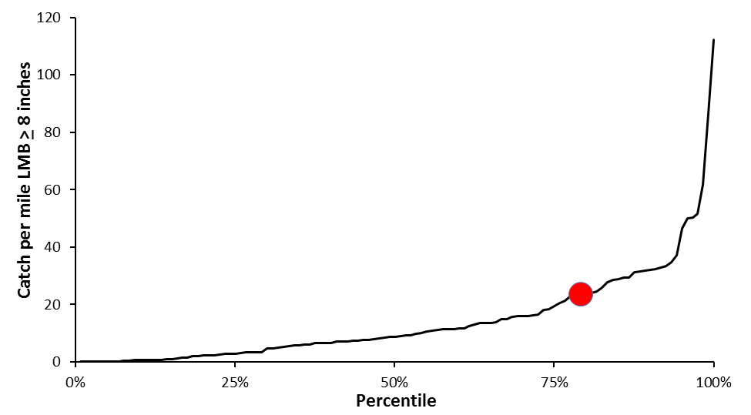
Figure 1. Relative abundance of the SECL largemouth bass population, indexed using catch per mile during bass electrofishing surveys, compared to all other lakes that have been surveyed for largemouth bass in the "Headwaters Region" of Wisconsin, 2000-2013 (N=120).

A total of 793 different largemouth bass were captured during spring surveys of the SECL during 2011(Table 3, Appendix A). The data collected during our mark-recapture survey estimated the largemouth bass population to be approximately 3,482 fish > 8.0 inches (7.41/acre) for the navigable portion of the SECL. Since largemouth bass spawning habitat is present throughout the entire chain of lakes it is reasonable to assume that East and South Lakes carry the same density of adult largemouth bass. By making this assumption we can extrapolate a population estimate of 4,061 fish > 8.0 inches in the entire SECL. This was the first time the largemouth bass population had been estimated in the SECL, in fact, it was the first time that the technique of electrofishing was used to sample largemouth bass. Without historical bass electrofishing survey data I cannot make comparisons to previous bass population levels.

Size Structure

During 2011 we sampled a total of 793 different largemouth bass up to 21.4 inches in total length (Figure 9). The average length of adult largemouth bass captured during 2011 was 12.4 inches with the majority of the bass sampled (68.1%) were between 10.0 and 14.9 inches.

Size structure, indexed using relative stock density (RSD), has not changed significantly since 1998 (Table 5). The size structure of largemouth bass measured in 1998 and 2011 is much higher than the previous surveys conducted in 1979 and 1949. At present, approximately 54% of the stock length largemouth bass are larger than 12.0 inches, 11% > 15.0 inches and less than 2% > 18.0 inches in length, which is well below average for Florence County.

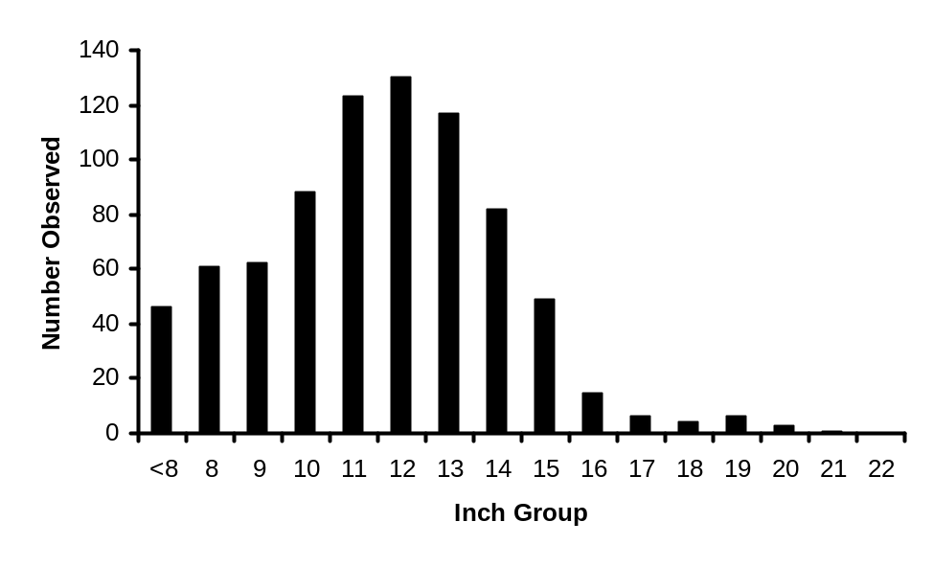
Figure 9. Length frequency of largemouth bass captured during spring fyke netting and electrofishing surveys of the Spread Eagle Chain of Lakes, Florence County, 2011 (N=793).

Table 5. Size structure, indexed using relative stock density, for largemouth bass captured during 2011 compared to previous surveys of the Spread Eagle Chain of Lakes, Florence County (2011: N=747).
 | 2011 | *2011 | *1998 | *1979 | 1949
RSD12 | 54.49 | 53.57 | 59.57 | 17.44 | 12.50
RSD15 | 11.10 | 10.71 | 12.77 | 0.00 | 0.00
RSD18 | 1.83 | 7.14 | 6.38 | 0.00 | 0.00
RSD20 | 0.56 | 0.00 | 2.13 | 0.00 | 0.00
 | *Spring fyke netting only

Growth

During most of our sampling effort we were unable to visually determine the sex of largemouth bass, so fish of both sexes were grouped into a single category of unknown sex largemouth bass. Scales were collected from a subsample of 130 largemouth bass to estimate age. Growth was then inferred using average length at age compared to the average for the Northern Region (NOR) of Wisconsin (Figure 10). The SECL largemouth bass population exhibited slightly below average growth until age 7 and above average growth beyond age 8 when compared to other populations in the NOR of Wisconsin (Table 4, Appendix B). On average it takes largemouth bass in the SECL 6 years to reach the minimum size limit of 14 inches.

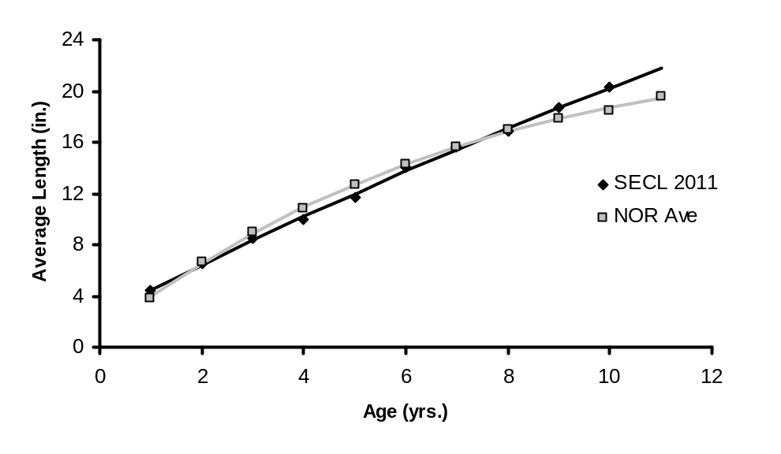
Figure 10. Average length at age for largemouth bass captured from the Spread Eagle Chain of Lakes during 2011 spring surveys, fit with von Bertalanffy growth curves and compared to the average length at age for the Northern Region of WI (2011: N=130).

Body Condition

A total of 119 randomly selected fish were weighed during our spring surveys to assess body condition of largemouth bass via relative weight analysis. W_{r} values for both sexes combined ranged from 89.7 to 105.0, with an average value of 98.8 (Figure 11). This average is very close to the target average of 100 showing that bass have a good body condition in the SECL. Largemouth bass showed very little change in W_{r} with length, this suggests that conditions are very good for largemouth bass of all sizes within the SECL.

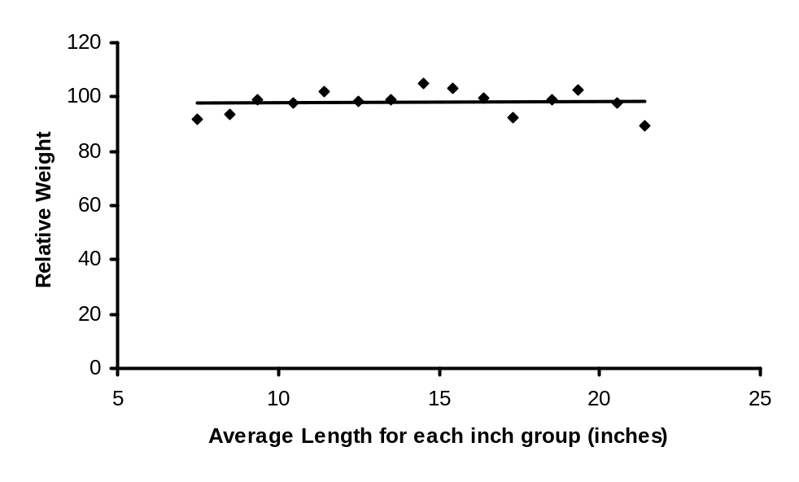
Figure 11. Average relative weight at length, measured from a sub sample of largemouth bass captured during spring surveys of the Spread Eagle Chain of Lakes, Florence County, 2011 (N=119).

Recruitment

During our fall electrofishing survey we attempted to index recruitment of all gamefish using average catch per mile of young-of-the-year (YOY) gamefish. However, the survey had an emphasis on walleye so other gamefish, including largemouth bass, were only captured if walleyes were not present, which does not allow us to get an accurate sample of YOY and Age-1 largemouth. We did capture 4 age-1 largemouth bass ranging from 5.0-6.4 inches in length during our recruitment survey. The small sample of juvenile bass captured during this survey would not be enough to maintain a density of 7+ adults/acre. However, the presence of all year classes age 1-10 during our survey and fairly even year classes from age 2-9 along with no documented stocking of largemouth bass since 1942 proves the population is capable of sustaining itself at or near the current level.

Smallmouth Bass

Abundance

Smallmouth bass were the least abundant gamefish species captured during both of the 2011 spring fyke net surveys (Table 1 & 3, Appendix C). However, at the average catch rate of just over 2 fish per mile they were the 2nd most abundant game fish species during our spring electrofishing surveys (Table 6, Appendix C). Low catch rates prevented us from being able to estimate the abundance of the population, suggesting that smallmouth bass are less abundant than all gamefish, except walleyes and muskellunge, in the SECL.

Electrofishing surveys were not used to assess the smallmouth bass population before 2011, so comparisons of the current population to historical surveys can only be made based on spring fyke netting catch rates. The 2011 catch rate of 0.09 fish per net lift is lower than the rate of 0.28 fish per net lift measured in 1998, suggesting a potentially declining population. However, fyke nets are not a good method to capture bass and little stock should be put into these catch rates.

Size Structure

During 2011 we captured 65 different adult smallmouth bass up to 18.1 inches during spring sampling (Table 4, Appendix A). The average length of smallmouth bass captured during spring surveys was 12.5 inches, with a mode of 10 inches (Figure 12). Size structure, indexed using relative stock density (RSD), has continued to improve since the first sampling of smallmouth bass in 1949 (Table 6). The current size structure is pretty good with nearly 31% of the stock length fish being > 14.0 inches in length.

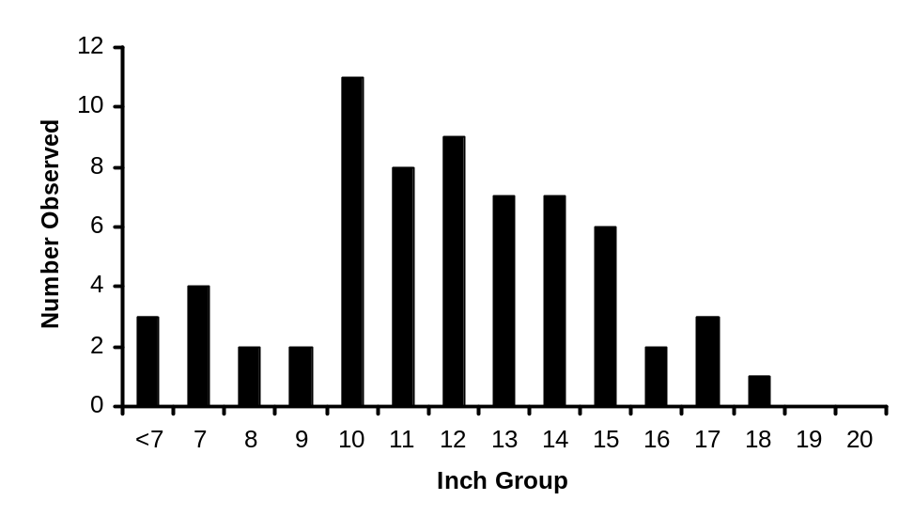
Figure 12. Length frequency of smallmouth bass captured during spring fyke netting and electrofishing surveys of the Spread Eagle Chain of Lakes, Florence County, 2011 (N=65).

Table 6. Size structure, indexed using relative stock density, for smallmouth bass captured during 2011 compared to previous surveys of the Spread Eagle Chain of Lakes, Florence County (2011: N=65).
 | 2011 | *1998 | 1949
RSD11: | 69.35 | 45.45 | 14.29
RSD14: | 30.65 | 27.27 | 0.00
RSD17: | 6.45 | 4.55 | 0.00
RSD20: | 0.00 | 0.00 | 0.00
 | *Spring fyke netting only
Growth

Growth was indexed using average length at age from a subsample of 57 smallmouth bass during the 2011 survey (Figure 13). SECL smallmouth bass showed growth that was initially above the Northern Region average, but declining to below the NOR average after age 4 (Table 3, Appendix B).
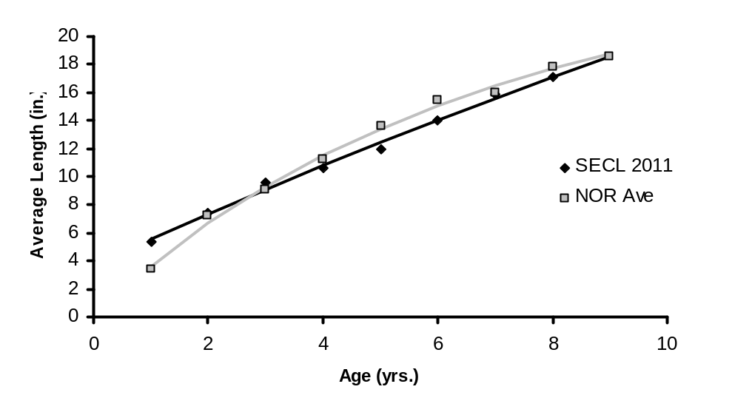
Figure 13. Average length at age for smallmouth bass captured from the Spread Eagle Chain of Lakes during 2011 spring surveys, fit with von Bertalanffy growth curves and compared to the average length at age for the Northern Region of WI (2011: N=57).

Body Condition

During our sampling efforts we obtained weight measurements from 54 of the 65 smallmouth captured. Relative weight (Wr) was used to index body condition of smallmouth bass. Wr values for both sexes combined ranged from 77.0 to 100.6, with an average of 85.7 (Figure 14). These are acceptable values of Wr for smallmouth bass in our northern climate. However, linear regression analysis shows that there is a significant negative correlation between relative weight and length for smallmouth bass in the SECL (P=0.05, R²=0.33). This negative relationship between body condition and length suggest that conditions are better in the SECL for shorter/younger smallmouth bass and lacking for longer/older individuals.
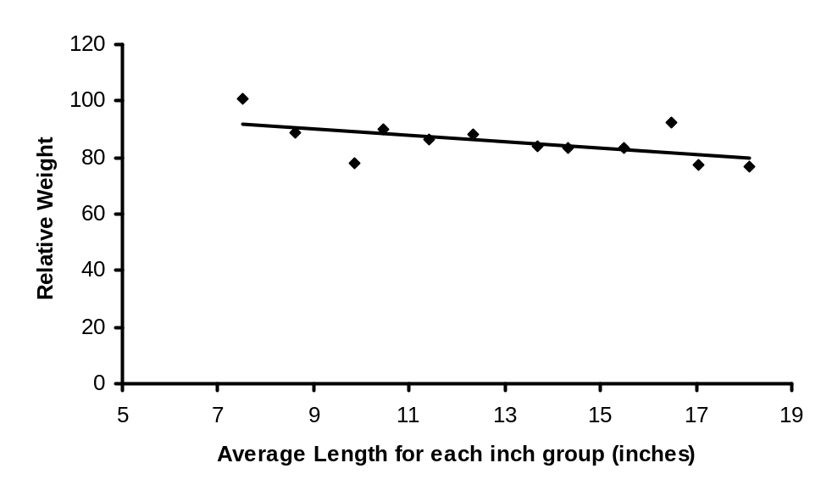
Figure 14. Average relative weight at length, measured from a sub sample of smallmouth bass captured during spring surveys of the Spread Eagle Chain of Lakes, Florence County, 2011 (N=54).

Recruitment

Recruitment was indexed using catch per mile of YOY and age 1 fish during a 7.3 mile fall electrofishing survey. No YOY and only a single age-1 smallmouth were captured during this survey. This does not show great natural reproduction of smallmouth bass in the SECL, however, the presence of year classes 1 through 8 during the survey suggest that there is enough natural reproduction to support this small population.

MANAGEMENT RECOMMENDATIONS FOR SPREAD EAGLE CHAIN (AT TIME OF SURVEY)

Largemouth Bass

Largemouth bass are the most abundant gamefish in the SECL. Currently they provide the best sport fishing opportunity. However, the population is over abundant at 7+ adults per acre. Largemouth bass maintain average to above average growth rates even at this high density. The largemouth bass length frequency shows a sharp decline in number observed beyond the minimum size limit. With the growth rates displayed by this population there is no reason for such a drastic decrease accept high mortality rates, likely caused by angler exploitation. This leads me to believe that anglers are willing to and currently harvesting bass in significant numbers from the SECL.

Since the population is over abundant and has seemingly high recruitment (with all year classes present) a more liberal regulation may help reduce bass abundance and provide a harvest opportunity. No minimum length limit would be my recommendation for the SECL bass regulation. Potentially a “no minimum” with a protected slot from 14 to 18 inches and only 1 fish over 18 inches or a “no minimum” with 1 fish over 14 inches with a daily bag limit of 3 would be the most beneficial. These regulations would offer protection to quality fish to maintain a quality size structure while increasing harvest of juvenile and young adult fish which should decrease abundance overall providing a better fishing experience.

Smallmouth Bass

The smallmouth bass fishery in the SECL is quite minor. Since they are significantly less abundant than largemouth bass I believe a minimum size limit should be maintained on smallmouth bass in an effort to maintain or grow the population and create a more diverse fishery. If there is a concern for misidentification of bass species posters could be posted at the boat launch.

Keyes Lake 2012
The complete report can be found at http://www.exploreflorencecounty.com/tourism/recreation/ ← just scroll down to “fishing”

Largemouth Bass
Abundance

Spring netting, early spring electrofishing along with five other spring electrofishing surveys were conducted to estimate the abundance of adult largemouth bass in Keyes Lake during 2012. These surveys captured 418 different largemouth bass (Table 3, Appendix A). The data obtained from these surveys estimate the adult largemouth bass population to be approximately 1,000 fish > 8.0 inches (4.95/acre) with a 95% confidence range between 712 and 1,288 fish. This largemouth bass population is nearly three times the size of the population during the early 2000’s and the largest population every measured in Keyes Lake (Table 6). The average catch rate of adult largemouth bass during bass electrofishing surveys was very high at approximately 22.2 adults/mile, which puts this population at the 76th percentile when comparing the Keyes Lake population to all other waters that have been surveyed for bass in our six county area (Figure 9).

Table 6. Abundance of largemouth bass, indexed using population estimation and catch rate during spring electrofishing surveys, in Keyes Lake during 2012 compared to previous surveys of Keyes Lake.
 | 2012 | 2007 | 2005 | 2000 | 1990
Adults/Acre | 4.95 | 3.90 | 1.70 | 1.70 | n/a
Adults/mi. | 22.18 | n/a | n/a | 11.09 | 22.9

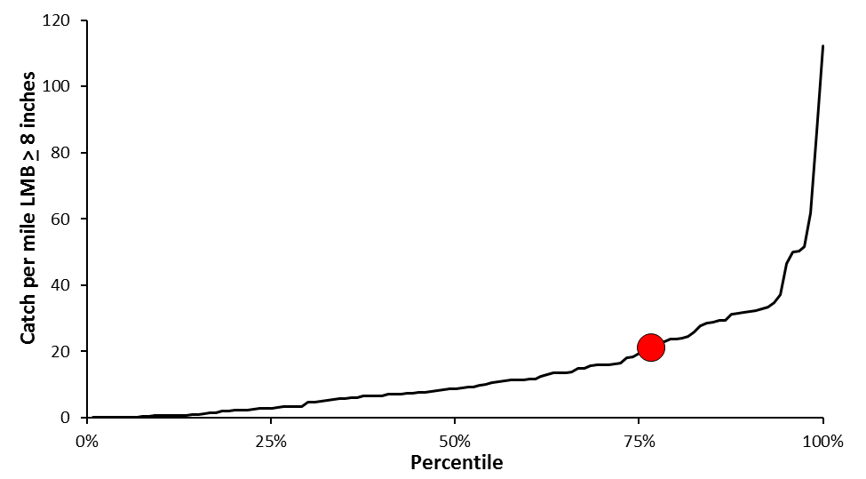
Figure 9. Relative abundance of the largemouth bass population in Keyes Lake, indexed using adult catch per mile during bass electrofishing surveys, compared to all other lakes that have been surveyed for largemouth bass in the "Headwaters Region" of Wisconsin, 2000-2013 (N=120).

Size Structure

During 2012 we sampled a total of 418 different largemouth bass up to 18.5 inches in total length (Figure 10). The average length of largemouth bass captured (> 8.0 inches) during 2012 was 12.6 inches, almost one inch larger than the average size of 11.7 inches in 2000. During 2012, the majority of the bass sampled (67.7%) were between 11.0 and 14.9 inches showing that the bulk of the fish present are substantially larger than in 2000 when 62% of the catch was between 9.0 and 11.4 inches.

Size structure, indexed using relative stock density (RSD), has increased since 2000 when comparing RSD12 values, which have doubled (Table 7). However, RSD15 and 18 values have decreased by approximately 50% since 2000. At present, approximately 67% of the stock length largemouth bass are larger than 12.0 inches, 8% > 15.0 inches and less than 1% > 18.0 inches in length. The current size structure is below average and is something that could use improvement.

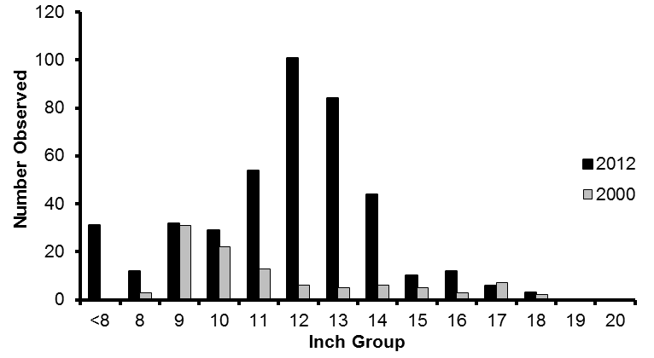
Figure 10. Length frequency of largemouth bass captured during spring surveys of Keyes Lake, Florence County, in 2012 compared to 2000 (2012: N=418; 2000: N=103).

Table 7. Size structure, indexed using relative stock density, for largemouth bass captured during 2012 compared to previous surveys of Keyes Lake, Florence County.
 | 2012 | 2000 | 1990
RSD12 | 67.18 | 33.01 | 15.38
RSD15 | 8.01 | 16.50 | 3.30
RSD18 | 0.78 | 1.94 | 2.20
RSD20 | 0.00 | 0.00 | 0.00

Growth

During most of our sampling effort we were unable to visually determine the sex of largemouth bass, so fish of both sexes were grouped into a single category of unknown sex largemouth bass. Dorsal spines were collected from all fish > 8.0 inches and scales were collected from fish < 7.9 inches. A total of 109 largemouth bass were aged during 2012. Growth was then inferred using average length at age and compared to the average for the Northern Region (NOR) of Wisconsin (Figure 11). Keyes Lake largemouth bass exhibited below average growth throughout their entire life; when compared to other populations in the NOR of Wisconsin (Table 3, Appendix B). Growth of Keyes Lake largemouth bass has been steady since 1997. On average it takes largemouth bass in Keyes Lake just over 7 years to reach the minimum size limit of 14 inches.

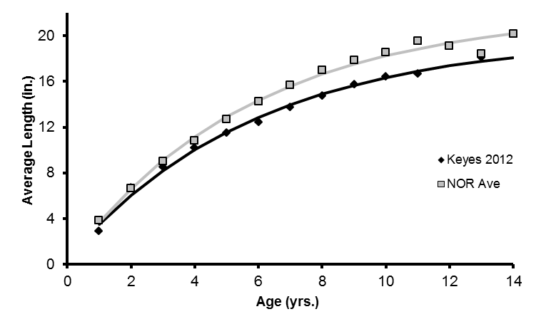
Figure 11. Average length at age for largemouth bass captured from Keyes Lake during 2012 spring surveys, fit with von Bertalanffy growth curves and compared to the average length at age for the Northern Region of WI (2012: N=109).

Body Condition

A total of 73 randomly selected fish were weighed during our spring surveys to assess body condition of largemouth bass via relative weight (W_{r}) analysis. W_{r} values for both sexes combined ranged from 106.0 to 121.8, with an average value of 112.3 (Figure 12). This average is well above the target of 100, showing that largemouth bass have very good body condition in Keyes Lake. There is no correlation between W_{r} and body length suggesting that conditions are great for all sizes of largemouth bass in Keyes Lake.

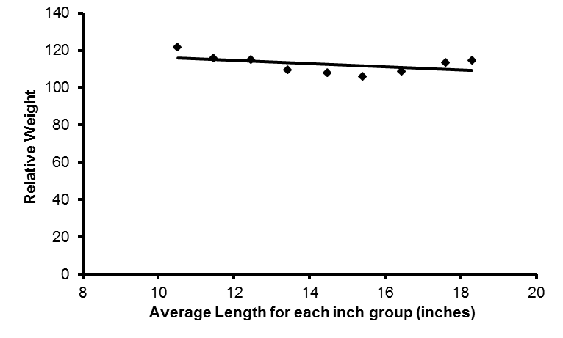
Figure 12. Average relative weight at length, measured from a sub sample of largemouth bass captured during spring surveys of Keyes Lake, Florence County, 2012 (N=73).

Recruitment

During our fall electrofishing survey we attempted to index recruitment of all gamefish using average catch per mile of young-of-the-year (YOY) gamefish. However, the survey had an emphasis on walleye so other gamefish, including largemouth bass, were only captured if walleyes were not present, which does not allow us to obtain the best sample of YOY and Age-1 largemouth. We did capture 1 YOY largemouth bass during our recruitment survey. This single fish and the presence of all year classes age 1-11 during our survey, along with an abundant adult population, suggests largemouth bass are capable of sustaining their population at or near the current level.

Smallmouth Bass

Abundance

A total of 75 different smallmouth bass were captured during our spring surveys in 2012 (Table 4, Appendix A). Smallmouth bass were the least abundant gamefish species captured during the 2012 spring fyke net survey (Table 1, Appendix C). A mean catch rate of just over 3 adult smallmouth bass per mile was found during spring electrofishing surveys; making smallmouth bass the 2nd most abundant fish species captured during these surveys (Table 5, Appendix C). This is a relatively low catch rate which prevented us from being able to estimate the abundance of the population. After comparing the 2012 catch rate to previous bass surveys it appears that the smallmouth bass population is decreasing in Keyes Lake (Table 8). Surveys conducted during 1990 and 2000 showed similar catch rates of smallmouth bass, indicating a fairly stable population size at that time. The 2012 mean catch rate is approximately 57% lower than the average catch rate during 1990 and 2000, suggesting that the smallmouth bass population has declined to near 1 adult/acre.

Table 8. Abundance of smallmouth bass, indexed using population estimation and catch rate, during 2012 spring surveys compared to previous surveys of Keyes Lake, Florence County.
 | 2012 | 2007 | 2000 | 1990
Adults/Acre | n/a | 1.50 | 2.20 | n/a
Adults/mi. | 3.07 | n/a | 9.38 | 9.00

Size Structure

The 75 different smallmouth bass captured during 2012 ranged in size from 5.6 to 20.5 inches in length (Figure 13). The mean length of smallmouth bass captured during spring surveys was 11.5 inches, very close to the 11.3 inch average measured during 2000. Modal length of smallmouth bass during 2012 (13 inches) was substantially higher than during 2000 (8 inches). Size structure, indexed using relative stock density (RSD), has improved since 2000 (Table 9). The current size structure is acceptable, with 25% of the stock length fish being > 14.0 inches and 1.5% of trophy length (> 20.0 in.).

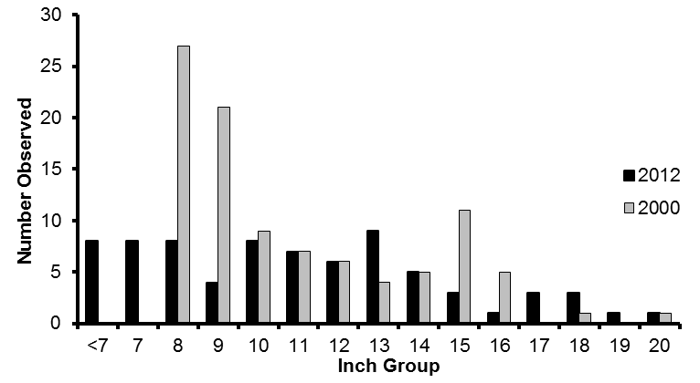
Figure 13. Length frequency of smallmouth bass captured during spring surveys of Keyes Lake, Florence County, in 2012 compared to 2000 (2012: N=75; 2000: N=97).

Table 9. Size structure, indexed using relative stock density, of smallmouth bass captured during 2012 compared to previous surveys of Keyes Lake, Florence County.
 | 2012 | 2000 | 1990
RSD11: | 58.21 | 41.24 | 51.22
RSD14: | 25.37 | 23.71 | 34.15
RSD17: | 11.94 | 2.06 | 12.20
RSD20: | 1.49 | 1.03 | 0.00

Growth

Growth was indexed using average length at age from a subsample of 71 smallmouth bass captured during the 2012 survey (Figure 14). Keyes Lake smallmouth bass showed growth rates slightly below the Northern Region average. The 2012 growth data is similar to growth rates measured during previous surveys of Keyes Lake (Table 4, Appendix B).
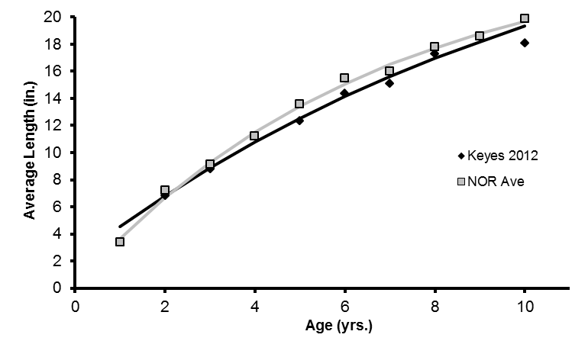
Figure 14. Average length at age for smallmouth bass captured from Keyes Lake during 2012 spring surveys, fit with von Bertalanffy growth curves and compared to the average length at age for the Northern Region of WI (2012: N=71).

Body Condition

During our sampling efforts we obtained weight measurements from 65 of the 75 different smallmouth captured. Relative weight (W_{r}) was used to index body condition of smallmouth bass. W_{r} values for both sexes combined ranged from 132.0 to 72.5, with an average of 109.1 (Figure 15). The average W_{r} for smallmouth bass sampled is above the target of 100, however, the sample was biased toward shorter/younger individuals with 53 of the 65 fish sample < 15.0 inches in length. A statistically significant negative correlation was found between body length and W_{r} (P=2.4x10⁻⁸, R²=0.93). This suggests that conditions are better for shorter/younger individuals than they are for longer/older individuals in the population, some of the more likely conditions that are worse for longer/older individuals are forage supply and quality, space, and ideal water temperature. A negative relationship between body length and body condition has been seen in many different waters in this region of Wisconsin. While it is not desirable to have a negative relationship between total length and body condition, the average W_{r} for the 12 fish > 15.0 inches was 88.9, an acceptable value for our northern climate.
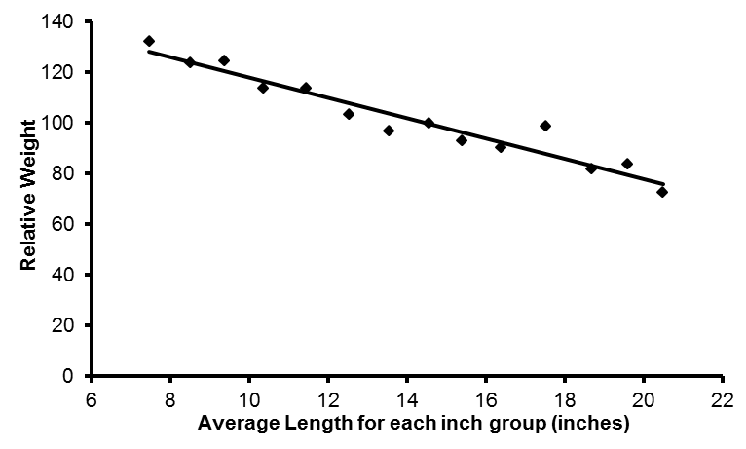
Figure 15. Average relative weight at length, measured from a sub sample of smallmouth bass captured during spring surveys of Keyes Lake, Florence County, 2012 (N=65).

Recruitment

Recruitment was indexed using catch per mile of YOY and age 1 fish during a fall electrofishing survey. Smallmouth bass recruitment is present but appears to be low in Keyes Lake with three age-0 and two age-1 fish sampled. Like largemouth bass, this does not show great natural reproduction of smallmouth bass, however, the presence of all year classes 1 through 10 during the survey suggest that there is enough natural reproduction to support this small population.

MANAGEMENT RECOMMENDATIONS FOR KEYES LAKE (AT TIME OF SURVEY)

Largemouth Bass

Largemouth bass are the most abundant gamefish in Keyes Lake. The bass population has nearly tripled in the past 8 years from a density of 1.7 to 4.95 adults per acre. At just under 5 adults per acre the Keyes Lake bass population would be considered abundant and if the population continues to grow it could become overabundant.

The average length of largemouth bass has increased since 2000. The increase in average size was reflected by a two-fold increase in RSD12 since 2000. However, RSD15 and 18 both decreased by approximately 50% since 2000. A decrease in size structure is usually expected in a population that is increasing its abundance. This is normally due to a higher level of competition between the species for resources. However, body condition analysis shows that resources are not limited for largemouth bass, expressed by an average W_{r} of 112, suggesting that intraspecific competition is likely not a problem at this time. Length frequency analysis shows a large decline in the number of individuals captured beyond 14 inches. This leads me to believe that angler harvest is likely high for largemouth bass and is likely limiting size structure.

Like body condition, growth of largemouth bass does not appear to have been negatively affected by the recent increase in largemouth bass abundance. However, largemouth bass growth in Keyes Lake is below the average for the Northern Region of Wisconsin. With this slow growth rate a largemouth bass must live a very long time to achieve trophy size, because of this I do not see any reason to manage Keyes Lake for trophy largemouth bass, or with a restrictive regulation to manage for higher size structure.

If the Keyes Lake population continues to grow a more liberal regulation should be considered. Right now the best option would be, no minimum length limit with a protected slot on fish between 14 and 18 inches with a daily bag limit of 3 (only 1 of which can be >18 inches). If the option for a no minimum size limit, daily bag limit of 3 fish, with only 1 fish > 14 inches (or something similar) became available it may be an even better option. Both of these more liberal regulations would allow for harvest of smaller individuals and protect larger fish which is appropriate for populations with high recruitment, which the expanding Keyes Lake population appears to have. Limiting harvest of the larger fish, instead of directing harvest toward larger fish like the current regulation, should also have positive impacts on size structure.

Smallmouth Bass

The smallmouth bass fishery in Keyes Lake is quite minor. Smallmouth bass exhibited better growth rates than largemouth bass. An effect of the good growth rates is a very respectable size structure with nearly 12% of fish being > 17.0 inches.

Body condition had a significant negative correlation with body length for smallmouth bass in Keyes Lake. This same trend is seen on many of the other lakes in Florence County, suggesting something about this region is limiting body condition on longer/older fish. The most likely problem is a lack of preferred forage for larger smallmouth bass. That being said, larger smallmouth bass were still within the acceptable range of body condition for Northern Wisconsin.

Since smallmouth bass are of such low abundance a minimum size limit should be maintained on smallmouth bass in an effort to maintain or grow the population and create a more diverse fishery. A special regulation restricting harvest would make sense on Keyes Lake, but is not needed at this point in time.

Halsey Lake 2013
I have not finished the comprehensive report for this lake yet, however you can see a short summary of the fish community by going to this website: http://www.exploreflorencecounty.com/tourism/recreation/ ← just scroll down to “fishing”

Abundance

Largemouth bass were captured during our spring fyke net survey, walleye electrofishing survey and 4 nights of bass electro-fishing to estimate the adult population. During these surveys we captured and measured 354 different largemouth bass (Figure 1). After analyzing the data I estimate there to be approximately 911 largemouth bass > 8.0 inches (1.8/acre) in Halsey Lake. However, due to the layout of this lake (topography and substrate) only about half of the shoreline, and a small percentage of suitable nesting habitat can be surveyed effectively with our electrofishing equipment. This population estimate did not sample the entire lake, just the “navigable” area with hard substrate and should be considered nothing more than the minimum number of adult largemouth bass in Halsey Lake.

The best way to index abundance of largemouth in Halsey Lake is using the average catch rate of adult fish during SEII electrofishing surveys. During these surveys we captured an average of 28.88 adult largemouth bass per mile, when you compare that to all other lakes in our six county area this population ranks in the 86th percentile for relative abundance (Figure 1).

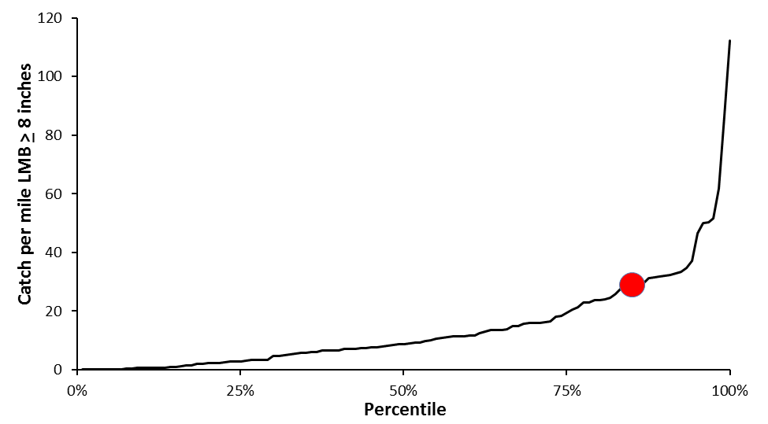
Figure 1. Relative abundance of the largemouth bass population in Halsey Lake, indexed using adult catch per mile during bass electrofishing surveys, compared to all other lakes that have been surveyed for largemouth bass in the "Headwaters Region" of Wisconsin, 2000-2013 (N=120).

Since only a small portion of the littoral zone could be surveyed, it is more appropriate to estimate the adult largemouth bass population using the relationship between relative abundance and abundance that I have seen over the past few years (Figure 2). Based on this relationship I estimate that Halsey Lake has approximately 8.38 adults per acre.
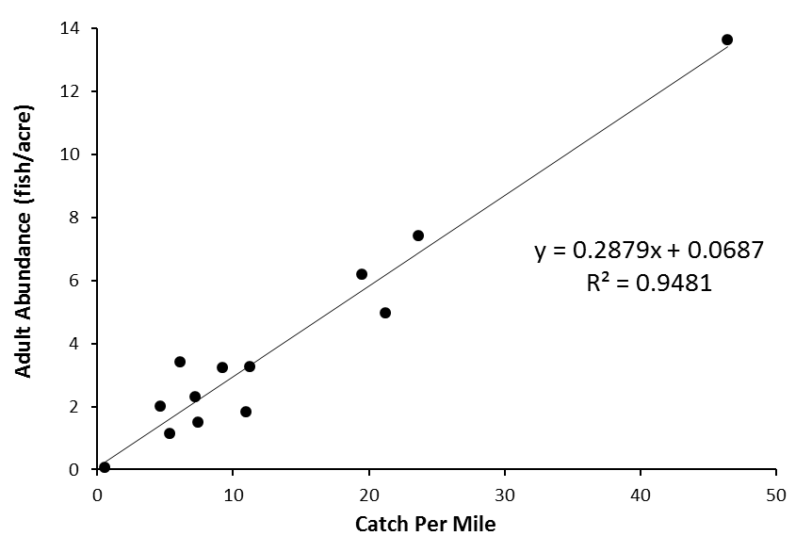
Figure 2. The relationship between adult largemouth bass relative abundance and abundance for Florence and Forest County populations surveyed 2011-2013 (N=13).

Size Structure

Every largemouth bass captured during spring 2013 was measured to analyze size structure (Figure 3). The size structure of largemouth bass population in Halsey Lake is extremely poor, with the majority of the largemouth bass captured (55.6%) between 8.0 and 9.9 inches in length. Only 17 fish (4.8%) were > 14 inches and one fish (0.3%) was larger than 18 inches in length (Table 1).

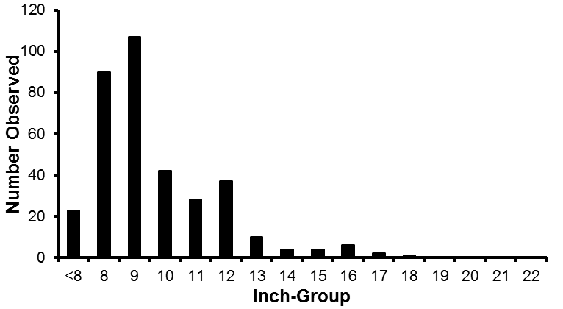
Figure 3. Length frequency of largemouth bass captured during spring surveys of Halsey Lake, Florence County, in 2013 (N=354).

Table 1. Size structure, indexed using relative stock density, for largemouth bass captured during 2013 surveys of Halsey Lake, Florence County (N=354).
RSD12 | 19.34
RSD15 | 3.93
RSD18 | 0.30
RSD20 | 0.00

*Growth data has been collected and will be analyzed this winter. With the poor size structure seen this spring the population either has very poor growth rates or fish are not surviving to old age*

MANAGEMENT RECOMMENDATIONS FOR HALSEY LAKE

The 2013 survey showed a very high relative abundance of largemouth bass, higher than any of the Florence County waters surveyed the last three years. Natural reproduction appears to be very high, based off of the 2013 fall young-of-the year CPUE of 9.7 fish/mile and age-1 CPUE of 5.8 fish/mile and the majority of the fish between 8 and 9.9 inches (thought to be relatively young). There is likely very little competition from other gamefish as the northern pike population is very small and walleye population has always been between 0.75 and 1.3 adults/acre through stocking.

The size structure of this population is quite pathetic with just less than 20% of the stock length fish being > 12 inches and less than 5% above the minimum length limit of 14 inches. The Halsey Lake population either has very poor growth rates or an abnormally high mortality rate. Either one of these two reasons would be a good reason to decrease the minimum size limit and increase harvest of juvenile/young adult largemouth bass. This winter I will gather more information on this population as I infer growth via average length at age.

Right now the bass population in Halsey Lake provides a poor fishing opportunity with almost no quality fish or fish available for harvest. The current regulation should be changed to try to increase size structure and harvest potential. I recommend the regulation be changed to no minimum length limit with a protected slot between 14 and 18 inches. The daily bag limit would be reduced from 5 fish to 3 fish per day (1 > 18”) with this regulation change. If indeed there are poor growth rates, this regulation would allow harvest of the abundant juvenile/young adult fish and likely increase growth rates to some degree. If growth rates are not the problem then the problem is likely high mortality, this regulation would allow these fish that are already experiencing early mortality to be harvested and utilized by the users of the resource. The protected slot limit should be more than enough to maintain the bass fishery, given the strong reproduction seen during the 2013 survey. Protecting larger fish via regulation will also help increase size structure by allowing large fish to stay in the system.

Basis for Special Regulation
Is the proposed regulation in the toolbox? Use survey data or provide context for a similar water or group of waters (e.g. lake type, spatial proximity) to demonstrate how the proposed regulation will help meet the management goal. Demonstrate expected results of the regulation using tools such as modeling, comparisons to other waters, peer-reviewed literature, etc.

Yes, this regulation is part of the current toolbox. I understand that the bass team has been looking at revamping the current regulation options. Please do not stop this regulation from going forward because there may be new options on the horizon, as this regulation is needed to improve the major game fishing opportunities on all three of these waters. If the bass team decides there are better options for regulations in the future (like a different slot, or a “1 over a certain size regulation) and we want to remove the 14-18” slot form the landscape all of these lakes could go to whatever the bass team recommends. But these lakes need to be managed at a “no minimum” with some increased protection to adults (slot or 1 over). If the bass team comes up with new options prior to the 2015 hearings, I would not object to this question being asked with a different regulation in place of the 14-18” slot limit.
Management Objectives of the Proposed Regulation
Objectives are used to evaluate the effectiveness of your action and determine if you have achieved your goal. Provide a management objective that is measurable and has a temporal component (e.g. increase walleye recruitment to 10/mile at least 3 out of 5 years and increase walleye PE from current 1.5/acre to 3 – 4/acre within 7 years; reduce largemouth bass relative abundance to less than 10/mile and increase RSD14 to 25).

The objective is to increase bass size structure in these three waters that currently exhibit poor size structure.

This regulation change will allow for size structure to be manipulated as an effect of reduced abundance/increased harvest of largemouth bass in these three waters that have abundant-to-overabundant bass populations.

Abundance

In order to have a significant impact on largemouth bass size structure the abundance of bass would likely need to decline. I think a reasonable goal for this regulation would be to reduce the abundance of largemouth bass by 15-25% within 13 years of the regulation change. Abundance should be measured by estimating the number of adult largemouth bass per acre in Keyes Lake and the SECL, and by relative abundance for Halsey Lake (since the layout of Halsey does not allow for precise estimation). The current abundance and abundance goals for these waters are listed below (Tables 1 & 2). If this goal is not met the regulation should not be viewed as a failure as long as the size structure goals are being met. However, if these “overabundant” populations display the same or increased abundance additional angler education or a more liberal regulation (possibly increased bag limit) should be considered to attempt to reduce the abundance in these waters to a more normal level.

Table 1. Current largemouth bass abundance, indexed via estimated abundance of fish > 8” per acre, and goal to be obtained by 2029 for the SECL and Keyes Lake.
 | 2011 | 2012
 | SECL | Keyes | Mean
Abundance | 7.41 | 4.95 | 6.18
Goal | 5.6-6.3 | 3.7-4.2 | 4.6-5.3

Table 2. Current relative abundance, indexed using average catch-per-mile during SEII surveys, standing within the “Headwaters Region” of WI, displayed as a percentile rank, and goals to be obtained by 2029 for the three affected waters.
 | 2011 | 2012 | 2013
 | SECL | Keyes | Halsey | Mean
LMB > 8" | 23.66 | 21.12 | 28.88 | 24.55
Percentile (%) | 79 | 76 | 85 | 81
Goal | 17.7-20.1 | 15.8-18.0 | 21.7-24.5 | 18.4-20.9
Goal (%) | 73-75 | 69-73 | 76-81 | 74-76

Size Structure Objective

The second (and most important) part of the objective is to improve the size structure of largemouth bass in the SECL, Keyes and Halsey Lakes. In the next few paragraphs I will explain my rationale.

Currently the mean largemouth bass size for all waters > 75 acres with boat access (omitting Lake Ellwood) is 58.9, 34.6, 16.7, 5.8 and 0.8 for RSD12, 14, 16, 18, 20 respectively (Table 3). While the average size structure of the largemouth bass populations in the SECL, Keyes and Halsey Lakes is 47.2, 15.6, 4.3, 1.0 and 0.2 (Table 4). Average size structure on these three waters is approximately 20%, 55%, 74%, 83% and 77% lower than the Florence County average for RSD12, 14, 16, 18 and 20 respectively.

Table 3. Largemouth bass size structure, indexed using relative stock density, for all major waters in Florence County.
 | 2011 |  | 2012 |  |  |  | 2013
 | Patten | SECL | *Ellwood | Emily | Keyes | Sea Lion | Fay | Halsey | Long | Van Zile | Mean | Outlier Removed
RSD12 | 78.18 | 55.29 | 100.00 | 68.63 | 67.18 | 65.19 | 59.42 | 19.34 | 24.00 | 93.26 | 63.05 | 58.94
RSD14 | 60.91 | 22.22 | 93.33 | 30.39 | 19.38 | 38.52 | 44.93 | 5.14 | 16.00 | 74.16 | 40.50 | 34.63
RSD16 | 34.55 | 4.69 | 27.62 | 6.86 | 5.43 | 21.48 | 29.71 | 2.72 | 8.00 | 37.08 | 17.81 | 16.72
RSD18 | 21.82 | 1.87 | 0.95 | 0.49 | 0.78 | 9.63 | 10.87 | 0.30 | 4.00 | 2.25 | 5.30 | 5.78
RSD20 | 3.64 | 0.54 | 0.00 | 0.00 | 0.00 | 1.48 | 1.45 | 0.00 | 0.00 | 0.00 | 0.71 | 0.79
 | Outliers: *Reproductive Problems

Table 4. Largemouth bass size structure, indexed using relative stock density, for the three waters affected by this regulation change.
 | 2011 | 2012 | 2013
 | SECL | Keyes | Halsey | Mean
RSD12 | 55.29 | 67.18 | 19.34 | 47.27
RSD14 | 22.22 | 19.38 | 5.14 | 15.58
RSD16 | 4.69 | 5.43 | 2.72 | 4.28
RSD18 | 1.87 | 0.78 | 0.30 | 0.98
RSD20 | 0.54 | 0.00 | 0.00 | 0.18

I expect to see significant improvement in size structure in these three lakes that currently have poor size structure. The main objective for these waters is to increase largemouth bass size structure. A no minimum, with protected 14-18” slot, theoretically will have the most impact on RSD14 & 16 because fish in these categories will be safe from angler harvest until they move out the top end of the slot. A realistic goal for this group of lakes should be to increase RSD14 and 16 on these waters by 50-75% within 13 years of instituting this regulation (timeline chosen to fit sampling schedule), an average RSD14 value of 23.4-27.3 and RSD16 value of 6.4-7.5 for these three lakes by 2029. Each one of these waters will also be evaluated independent of each other to assess the regulation for that specific lake (Table 5). I expect to see increases in RSD18 and 20 with this regulation, however, I do not have a good handle on what the effect of removing the early catch and release season will have on these waters, and thus it should not be a goal of this regulation.

Table 5. Size structure goals, which should be obtained by 2029, for the three waters affected by this regulation change.
 | 2011 | 2012 | 2013
 | SECL | Keyes | Halsey | Mean
RSD14 | 33.3-38.9 | 29.0-33.9 | 7.7-9.0 | 23.4-27.3
RSD16 | 7.0-8.2 | 8.1-9.5 | 4.1-4.8 | 6.4-7.5

Smallmouth Bass

The regulation change proposal will affect smallmouth bass as well as largemouth bass in these three waters. I have included smallmouth bass in this regulation in an attempt to simplify regulations. I would be fine with maintaining a minimum size limit on smallmouth bass. However, I do not feel it is necessary. Halsey does not current contain smallmouth bass, while the SECL and Keyes Lake contain low density (Table 6), moderate size structure populations (Table 7).

Table 6. Relative abundance of smallmouth bass, indexed using average catch per mile during SEII surveys, for the SECL (2011) and Keyes Lake (2012).
 | SECL | Keyes | Mean
SMB | 2.04 | 3.92 | 2.98
SMB > 8" | 1.78 | 3.07 | 2.43

Table 7. Smallmouth bass size structure, indexed using relative stock density, for the two waters in Florence County that will be affected by this regulation change.
 | SECL | Keyes | Mean
RSD11 | 69.35 | 58.21 | 63.78
RSD14 | 30.65 | 25.37 | 28.01
RSD16 | 9.68 | 13.43 | 11.56
RSD18 | 1.61 | 7.46 | 4.54
RSD20 | 0.00 | 1.49 | 0.75

Smallmouth bass will continue to receive the protection of the early catch and release season (unlike largemouth bass) and I do not expect to see significant negative impacts to these populations. One can argue that adult abundance and recruitment is not high enough to make these waters a good fit for a “no minimum” regulation, and I share those concerns as well. However, the adult population will be fairly well protected and the population levels of smallmouth are so low that I do not think there will be an overwhelming amount of angler harvest. The gamefish species of interest on these waters is overwhelmingly largemouth. The quality smallmouth bass populations in this area are the flowages along the WI-MI border and they are not part of this regulation change.

Evaluation
When and how will the above objectives be measured and evaluated? What is the sampling schedule for this water including frequency and planned protocols?

The three waters that will be affected by this regulation are all on a baseline survey rotation receiving comprehensive surveys every 4 or 8 years (Table 1). During these surveys there will be bass population estimates attempted for largemouth and smallmouth bass. Data will also be gathered to analyze size structure, age & growth as well as body condition. This rotation will be more than enough to monitor the effects of the new regulation. These three waters will have surveys completed within 3-5 years of the implementation of this regulation to look at short-term impacts by 2021 and again by 2029 to analyze the long-term benefit (after 11-13 years) of the new regulation.

Table 1. Bass surveys scheduled for the three waters that will be affected by the requested regulation (“x” represents a year that bass population estimation surveys will be conducted).
 | YEAR
 | 14 | 15 | 16 | 17 | 18 | 19 | 20 |  | 21 | 22 | 23 | 24 | 25 | 26 | 27 | 28 | 29
SECL |  | x |  |  |  | x |  |  |  |  | x |  |  |  | x
Keyes |  |  | x |  |  |  | x |  |  |  |  | x |  |  |  | x
Halsey |  |  |  |  |  |  |  | x |  |  |  |  |  |  |  |  | x

All other waters in Florence County > 75 acres with boat access (7 other waters) will also be surveyed over this same timeframe and can serve as a reference set of lakes to account for natural changes over this timeframe.
Will the proposed regulation affect Ceded Territory water? Yes _x_ No __

If the water is usually declared and speared for tribal harvest, what is the typical bag limit adjustment for sport harvest regulations?

Keyes and Halsey Lakes are declared for walleye but rarely receive tribal harvest. There has not been significant bass harvest in Florence County by the Chippewa Tribes.

Are there any anticipated impacts to tribal fisheries?

No major impact anticipated. This regulation will reduce bass abundance on some waters that are being managed for walleyes. This could allow for better survival of stocked walleyes and benefit tribal walleye fisheries.
Are tournaments held on this water? Yes _x_ No __
If yes, please briefly describe frequency and type of tournaments.
There are two ice fishing tournaments on Keyes Lake annually. No permitted tournaments on the SECL or Halsey Lake.
Other factors When developing this proposal, did you consider:
Fish contaminant/consumption advice? Yes _x_ -this would focus harvest on younger/smaller fish which fits consumptive advice
How the regulations would affect males and females differently? Yes _x_ -bass do not display sexually dimorphic growth at the extremes that WE, NP and MU populations do. I expect to see increased harvest of both sexes of fish.
Predator – prey interactions? Yes _x_ -Abundance of bass should decline in these lakes, which have high density bass populations. None of these lakes have been shown to have poor panfish growth (where we would encourage high abundance of predatory fish). I foresee no negative impact.
Habitat availability? Yes _x_ Habitat is one of the many resources that will become more available to bass in these systems as bass abundance is reduced.
Effects of hooking mortality? Yes _x_ -There may be some hooking mortality of individuals in the protected slot, however, I do not see there being enough negative impact to outweigh the good results these fisheries will see form this regulation.
Attraction of additional angling pressure, if applicable? Yes _x_ - This regulation will allow for increased harvest in three waters where harvest would be helpful, and protect the larger (more desirable fish). This regulation will provide a more enjoyable bass fishing experience for bass anglers (those looking to consume and those looking to catch and release).
Alteration of nutrient cycling, if applicable? Yes __ - n/a
Proposal Instigation
Was this regulation change initially a Conservation Congress advisory question, requested by a lake association or another public group, or is it based on biological survey and other data you collected? Please describe.

After surveying all the major waters in Florence County over the past few years these three waters stood out. It was clear that the largemouth bass populations in these three waters could be better managed under a more consumptive regulation. It appears that the largest impact on bass size structure is likely angler harvest, with these waters showing extreme decrease in abundance and size structure beyond 14 inches (the minimum size limit). The harvest on these waters is reducing the quality fish creating less desirable bass fisheries. The impact currently seen on these waters indicates that the users of this resource are willing and would like to harvest bass. This regulation will allow more harvest and appease many anglers.

Public Participation
Was input solicited from stakeholders when developing the proposed regulation change? Include any contacts made with local Conservation Congress representatives, lake associations, angler groups, etc.

This regulation change is supported by the Florence County WCC represtative (Contact: Dale Ebbert & Peter D.).
This regulation change is supported by the SECL Association (Contact: Carl Sunberg)

On 9/20/2012 I held a meeting open to the public to go over all fish surveys conducted during 2012 and to discuss potential regulation changes for lakes in Florence County. At this meeting, after presenting on all the different surveys I handed out a questionnaire to see if the public supported the changes I was proposing. They supported the changes to the bass regulation on Keyes and SECL (32 of 32). *Halsey had not been surveyed yet*
Draft Question
This will be the question in the spring hearing questionnaire. Please use terms understandable to the general public using the following format.
This proposal would apply: a daily bag limit of 3 fish and no minimum length limit on largemouth and smallmouth bass, however all bass from 14 to 18 inches must be released and only 1 fish greater than 18 inches would be allowed for the Spread Eagle Chain of Lakes, Keyes Lake and Halsey Lake, Florence County.

The management goal is: to increase largemouth bass size structure by reducing abundance in these waters that currently have overabundant bass populations. It is currently not being met because the current 14-inch minimum length limit provides too much protection to largemouth bass in this area and focuses harvest on the quality fish.

This regulation proposal is one tool to help meet the management goal because: it will increase harvest opportunity on these high density bass populations, allowing those populations to decrease in abundance and increase growth rates while protecting quality sized fish.

Do you favor applying a daily bag limit of 3 fish and no minimum length limit on largemouth and smallmouth bass, however all bass from 14 to 18 inches must be released and only 1 fish greater than 18 inches is allowed per day, on the Spread Eagle Chain of Lakes, Keyes Lake and Halsey Lake, Florence County?

Example question:
This proposal would apply a daily bag limit of 3 fish and no minimum length limit on largemouth and smallmouth bass, however all bass from 14 to 18 inches must be released and only 1 fish greater than 18 inches is allowed in Trump Lake, Forest County. The current regulation is an 18-inch minimum length limit and daily bag limit of 1 fish. A Conservation Congress advisory question to change the bass regulations on Trump Lake was supported by spring hearing attendees in 2011.

The management goal is to improve bass growth and size structure, providing a bass fishery with a mix of ages and sizes in Trump Lake. It is currently not being met because of an overabundant population of small (less than 14-inch) bass. The objective is to increase the proportion of bass over 14 inches from 3% to over 15% within the next 10 years. This regulation is one tool to help meet the management goal because increased harvest of small bass is expected to improve growth rates by reducing competition, preserve a range of sizes by protecting 14 to 18 inch bass, and provide additional harvest opportunity.

Do you favor applying a daily bag limit of 3 fish and no minimum length limit on largemouth and smallmouth bass, however all bass from 14 to 18 inches must be released and only 1 fish greater than 18 inches is allowed, on Trump Lake in Forest County?

Regulation Proposal Checklist

Fish Team Supervisor

Reviewer  Mike Vogelsang | Date  11/08/2013
Are adequate data presented to justify the regulation change? Yes x No x

Is there adequate documentation that the proposed regulation will achieve the desired stated outcome?
Yes x No

Are the management objectives clear and complete? Yes x No

Reviewer Comments: (Is there additional information you want the author to provide before approving the proposal?)

Recommended Action: Approve x Reject

District Fish Supervisor
Reviewer | Date
Is the proposal necessary? -enforceable? -complete? Yes No

Does the proposal meet the district’s goal for providing varied fishing opportunities? Yes No

Is the proposed regulation easy for anglers to comply with and understand? Yes No

Reviewer Comments: (Is there additional information you want the author to provide before approving the proposal?)

Recommended Action: Approve Reject

Species Team
Reviewers  Jon Hansen on behalf o the Bass Team | Date  04/21/2014
Are adequate data presented to justify the regulation change? Yes x No

Does the proposal fit with statewide species management goals? Yes x No

Does the proposal meet regional and statewide goals for varied fishing opportunities? Yes x No

Are the management objectives clear and complete? Yes x No

Reviewer Comments: (Is there additional information you want the author to provide before approving the proposal?)
- BT approves. While these three populations do not have excessively high abundances of LMB compared to most waters in the north, they are some of the more dense populations in the area and size structure metrics are below target objectives. Thus, the protected slot seems warranted. Also, the author could be more targeted with the data presented.

Recommended Action: Approve x Reject

Law Enforcement Comments:
Please provide comments on enforceability of the reg proposal and other issues you think the Fisheries Management Board should consider.

